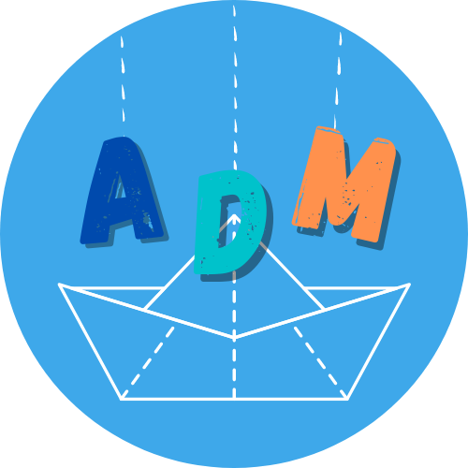

Festival Internazionale dei Burattini e delle Figure Arrivano dal Mare!
46th edition
21 - 26 May 2021 | Ravenna

ANIMATI IN VIDEO
THE FOUR ELEMENTS AND THE SPHERES OF HUMAN

Video contest

Application form
To be sent to festival@teatrodeldrago.it by 30 April 2021

PART 1: PERSONAL DATA

▢ Artist
▢ Company

First Name________________________ Last Name__________________________________
Company/Structure ____________________________________
Address_____________________________________________________________
Phone____________________________________________________
Email________________________________________________________________

Website/Facebook___________________________________________________

PART 2: VIDEO CONTENT

Title _______________________________________________________________
Lenght______________________________________________________________
Techniques _____________________________________________________

Short content description (max 2000 characters)

Short artist/company presentation (max 1500 characters)

Credits ________________________________________________________

is there a text? ▢ Yes ▢ No
If there is a text, please note that the video must be subtitles in English.

The candidate hereby acknowledges the conditions set out in the relative call and
▢ Declares that the sent video content is original and has not been published on other channels
▢ Accepts that the distribution of the video content takes place in the manner established by the call and at the discretion of the participating Festivals

PRIVACY
I,______________, having read the information issued pursuant to current legislation, containing the purposes of the processing of personal data provided by me and the rights inherent in the same, pursuant to and for the purposes of Articles 13 and 23 of Legislative Decree n. 196/2003 and EU Reg. 679/2016, I express my consent to the processing of the aforementioned data by Festival Internazionale dei Burattini e delle Figure Arrivano dal Mare.
We remind you that in case of selection these data will be provided to the project partner Festivals.
The submission of this application and the signature of the form constitutes a guarantee for the organization that the proposing structure has read and accepts the technical and administrative conditions described above.
Signature and date ________________________________

