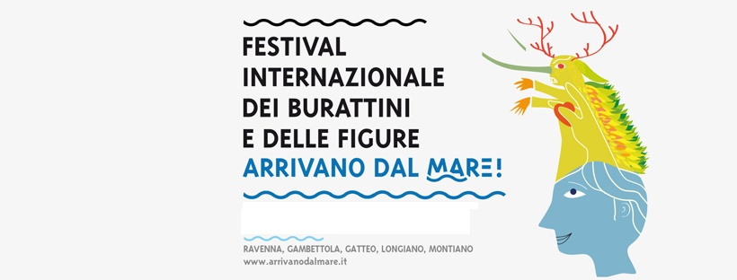
GenerAzioni
43° edizione
21 | 30 Settembre 2018
Ravenna |Cervia |Longiano |Gambettola| Gatteo

OPERATOR RESERVATION FORM
The form is personal, valid only for one operator and it's recorded in order of arrival

ORGANIZATIONAL STRUCTURE__________________________________________

NAME AND SURNAME____________________________________________________

ADDRESS/CITY/COUNTRY________________________________________________

PHONE__________________________________________________________________

E-MAIL__________________________________________________________________

Expected arrival time Day Time_____________________________________________

Expected departure time Day Time__________________________________________

MODE OF TRANSPORT___________________________________________________

At your arrival please stop at the FESTIVAL INFORMATION POINT for the registration and to get your information materials and your pass.
Complete and submit this form no later than September 10th 2018 to: info@teatrodeldrago.it

